#20190002 Trout Brook Watershed Restoration Project, Phase III
Grantee: Cumberland County Soil & Water Conservation District

- Waterbody and Watershed Information

a. Background
Waterbody Name | Trout Brook
Waterbody Size (e.g., lake acres, stream miles) | 2.9 mi
Watershed Area (acres or square miles) | 2.35 sq. mi
Watershed Town(s) | South Portland, Cape Elizabeth
Comprehensive Plan Adoption (List watershed towns that have adopted consistent plans.) | South Portland – 2012  Cape Elizabeth – In development for 2019
b. Waterbody and Watershed Physical Characteristics
Trout Brook is located in the City of South Portland and the Town of Cape Elizabeth. Trout originates in a wooded area west of Spurwink Avenue and then flows northward through mostly residential development with some agriculture and commercial development before entering Mill Cove, Portland Harbor, and Casco Bay. There are three tributaries to Trout Brook. The first tributary joins Trout Brook at the headwaters near Maxwell’s Farm (now known as Down Home Farm property). The second tributary meets the main channel just upstream of Mayberry Street in South Portland. And the third is Kimball Brook, which joins Trout Brook at the Highland Avenue bridge in South Portland.

Trout Brook is a low-gradient stream with low sinuosity. The width is variable, from 2m at summer baseflow to 6m bankfull width. The stream bed is composed of rubble, gravel, and sand with a few boulders, and the system is primarily a riffle-run morphology with some pools. The riparian buffer is less than 10m and is a matrix of wooded areas and lawn. The riparian zone in the upstream portions of the watershed consists of trees and understory plants and is mostly undisturbed. The middle and downstream portions have altered riparian buffers from lawns and invasive plants such as Japanese Knotweed.

c. Description of Waterbody Uses and Value
The predominant land use in Trout Brook is primarily residential development (50% of total land area) in both Cape Elizabeth and South Portland. Forested areas (30% of total area) are the next most prevalent land cover in the watershed.

Native brook trout have been documented in Trout Brook and its main tributary, Kimball Brook. Due to both its brook trout fishery and its proximity to several South Portland schools, there is significant local interest in Trout Brook. In addition to brook trout, several other native fish species have been documented in Trout and Kimball Brook, including American eel.
South Portland Schools and the Portland Water District continue to use Trout Brook as the location to release brook trout that they had raised during the year. South Portland schools use Trout Brook for experiential educational opportunities for students.

The South Portland Land Trust completed a Master Plan for the Trout Brook Preserve that will enhance the recreational opportunities provided by Trout Brook’s close proximity to densely populated residential areas. The Winnick Woods Master Plan received the Maine Association of Planners 2007 Plan of the Year Award for its proposal to manage part of Winnick Woods, in conjunction with the adjacent United States Fish and Wildlife Service (USFWS) land, as a habitat for the New England Cottontail.

The City of South Portland’s protected Sawyer Marsh is an 8-acre marsh that provides a rare scenic vista. Mill Creek Park is a ten-acre park at the bottom of the watershed. The City’s Master Plan identifies key restoration recommendations for Trout Brook’s riparian area. In addition, the South Portland Conservation Commission (SPCC) identified Trout Brook as an area where some of the City’s Wetlands Compensation Funds could potentially be used for restoration activities.

- NPS Pollution Problem / Need:

              - Water Quality Listing Status
Is water quality listed as impaired? | Yes
If impaired, what is the listed cause(s) and/or impaired use? | Aquatic life – Urban NPS
Name and date of any DEP TMDL report(s) for the waterbody. | Trout Brook Total Maximum Daily Load (TMDL) for Impervious Cover – 2007  ME Impervious Cover Total Maximum Daily Load Assessment (TMDL) for Impaired Streams – 2012

              - Water Quality Overview
Trout Brook is on Maine’s impaired waters list under federal Clean Water Act Section 303(d) for degraded aquatic habitat potentially caused by urban nonpoint source pollution. Trout Brook is also listed as an Urban Impaired Stream in Maine DEP’s Chapter 502, which means that it does not meet state and federal water quality classifications due to polluted runoff from impervious cover (IC). In August 2005, the Maine Department of Environmental Protection (DEP) completed an IC Total Maximum Daily Load (TMDL) for Trout Brook. Water quality sampling completed during the Watershed Management Plan indicated areas with low dissolved oxygen (DO), elevated phosphorus, and elevated chloride, and specific conductance.

              - Summary of Past Watershed Assessments and Most Important Nonpoint Sources
Trout Brook has been the subject of extensive study. In 2003, the South Portland Land Trust carried out a US Environmental Protection Agency (EPA) Clean Water Act (CWA) Section 604b-funded watershed survey and stream corridor assessment (#2002P10). Trout Brook was also included in DEP’s Urban Streams Study (2005) and Casco Bay Estuary Partnership’s fish barrier assessment (2009). Another CWA 604b grant funded the development of the Trout Brook Watershed Management Plan (#2010PT10). The plan summarized relevant data reports and surveys, and developed action plans for the following subwatersheds: upper Trout Brook, middle Trout Brook, lower Trout Brook, Mill Creek and Kimball Brook. The plan included the nine minimum elements considered by EPA to be critical for achieving improvements in water quality and required under the Nonpoint Source Program and Grant Guidelines for States and Territories (April 2013).

The Trout Brook Watershed Management Plan (2012) identified five goals: (1) address existing conditions; (2) prevent further decline of water quality; (3) implement a community outreach and education program; (4) conduct a monitoring program; and, (5) establish a Trout Brook Workgroup. Action items associated with restoring water quality included the following tasks: (1) Reduce nutrient loading from upper watershed from the golf course, farms and the intensely managed lawns at the top of the watershed and the dense residential areas in the mid-lower sections of the watershed; (2) Reduce chloride loading from middle watershed; and, (3) Improve stream habitat and address low baseflow.

              - Description of Watershed Activities to Address NPS Sources
Trout Brook Restoration Project Phase I (#2013RT08) was completed in 2015 with funding from USEPA under Clean Water Act (CWA) Section 319. Highlights of work completed during Phase I include:
- Removing invasive plants and replanting of 96,050 square feet of riparian area adjacent to Trout Brook. This work also increased local awareness of water quality issues and erosion mitigation techniques.
- Partnering and community building were hugely successful during Phase I, resulting in additional equipment and expertise leveraged in support of plan implementation and an increased sense of community and responsibility among participating neighbors.
- Identification of numerous potential projects to be completed using other funding sources (i.e., Trout Brook Youth Conservation Corps (YCC) National Estuary Program CWA Section 319 grant, South Portland Conservation Commission (SPCC), Trout Brook Phase II grant).

Trout Brook Restoration Project Phase II (#2014RT08) was completed in 2016 with another USEPA CWA Section 319 grant. Highlights of work completed during Phase II include:
- A covered manure storage facility was constructed south of the WHEC stable building to eliminate stormwater exposure of uncovered manure on the property.
- The LDS detention basin was rehabilitated to address nutrients and better manage roof runoff to reduce flow rates into the basin.
- Stream bank erosion at the edge of the LDS property caused by parking lot runoff was corrected with bank stabilization measures. To prevent future erosion issues and treat parking lot runoff, flow was redirected to an underdrained filter that cools the water and delays the peak discharge time.
- Two failing culverts were replaced at Down Home Farm eliminating the erosion of roadway materials into Trout Brook.
- A StormTree unit was installed to treat 0.5 acres of impervious surface on Boothby Avenue in South Portland.

- Purpose:
The purpose of this project is to achieve the goals of the Trout Brook Watershed Management Plan in reducing nutrient loading from upper watershed from farms and the dense residential areas in the mid-lower sections of the watershed, to ultimately restore Trout Brook so that it meets Class C water quality standards.
- Project Duration:
Project Start Date | January 2019
Project Completion Date | December 2020

- General Project Plan
The Trout Brook Restoration Project, Phase III will be administered by CCSWCD (Task 1). Project activities will be guided by the 2015 Trout Brook Watershed Management Plan and the Trout Brook Steering Committee will be invited to participate in the process (Task 2). Key project partners include City of South Portland, Town of Cape Elizabeth, Down Home Farm, Natural Resources Conservation Services (NRCS), and DEP. Education and outreach efforts (Task 4) and on-site construction projects (Task 3) will significantly reduce nutrient loading in the (agricultural) upper and (residential) mid-lower sections of the watershed.

Education and outreach tasks will be focused in South Portland neighborhoods are designed to foster sustained public involvement in stewardship of the watershed. The City of South Portland and CCSWCD will work together to form a local team of volunteers, called RainScapers, who will engage in traveling work parties to install rain gardens on residential properties throughout the watershed. These rain gardens will significantly reduce nutrient loading from residential lawns and will inspire long-term stewardship in the Trout Brook watershed.

Construction projects at Down Home Farm will be designed to address NPS sites on the property associated with livestock grazing, manure storage practices, and roadway failures/washouts of the farm road adjacent to the irrigation pond.

The Trout Brook Phase III project staff will exercise best professional judgment selecting NPS sites and designing / installing BMPs; use BMPs described Maine BMP guidance manuals, or BMPs otherwise acceptable to DEP; and ensure required permits are obtained prior to construction. Section 319 project funds will not be used to conduct work required by existing permits, consent decrees or orders. The project will be conducted within South Portland’s and Cape Elizabeth’s Urbanized Area designation. The project activities are not permit requirements under either’s Municipal Separate Storm Sewer System (MS4) General MEPDES permit effective July 1, 2013.

All press releases, outreach materials, project signs, and plans will acknowledge that the project is funded in part by the United States Environmental Protection Agency under Section 319 of the Clean Water Act. Project staff will consult with DEP on EPA’s public awareness terms and conditions for Section 319 grants before the project commences. In addition, project staff will consult with DEP and EPA before project signs are designed. Refer to the Grant Agreement, Rider A. Section III. F. Acknowledgement.

VI. Tasks, Schedules and Estimated Costs:

Task 1 – Project Administration
CCSWCD will administer the project according to the grant agreement with DEP. CCSWCD will track project progress, expenses and local match, and complete semi-annual progress reports and a final report. CCSWCD will update the Trout Brook Watershed NPS Site Tracker with sites that are addressed and will provide DEP with updated spreadsheet as part of the final report.
Start and Completion Dates | January 2019 – December 2020
Grant Cost: $3,131.37 | Match Cost: $0 | Total Cost: $3,131.37
Breakdown of Grant by Cost Category: $3,131.37 Salary, Fringe, and Indirect
Breakdown of Match by Cost Category: $0

Task 2 – Steering Committee
The Trout Brook Workgroup / Steering Committee will guide project activities during the grant period. This committee includes representatives from Down Home Farm, Cape Elizabeth, South Portland, NRCS, CCSWCD, and DEP. The Committee will hold three meetings, including a project kick-off meeting, a mid-point check-in meeting, and a project wrap-up meeting with quarterly check-in conference calls.

Start and Completion Dates | January 2019-December 2020
Grant Cost: $2,569.18 | Match Cost: $1,682.08 | Total Cost: $4,251.26
Breakdown of Grant Cost by Cost Category: $2,475.58 Salary, Fringe, and Indirect; $93.60 Travel
Breakdown of Match by Cost Category: $1,682.08 Donated Time

Task 3 – Down Home Farm Improvement Projects
Nutrient loading from nonpoint sources at Down Home Farm will be addressed through three separate construction projects on site, listed as Sub-Tasks 3a through 3c below. CCSWCD will complete NPS site reports for all sites addressed in Task 3 and submit draft designs for tasks 3b and 3c for DEP review. CCSWCD will develop a long-term operations and maintenance (O&M) plan for structures constructed at Down Home Farm. CCSWCD will execute a cost-share agreement with Down Home Farm, ensuring adherence to the O&M plan.
Grant: $530.76 Match: $0 Total: $520.76

Sub-Task 3a – Livestock Fencing
Existing livestock fencing at Down Home Farm does not completely exclude livestock from entering Trout Brook. This causes erosion of stream banks and introduces animal waste into the stream channel when animals access the stream. Down Home Farm will install an additional 680’ of livestock fencing along Trout Brook to prohibit livestock from entering. Grant funding will pay for fencing materials; installation will be in-kind labor donated by Down Home Farm.
Grant: $2,755.94 Match: $2,000.00 Total: $4,755.94

Sub-Task 3b – Manure storage shed
Down Home Farm currently keeps eight (8) pigs on site. Existing conditions for the swine consist of an open-fenced area and small storage trailer. Manure is stored outside, within the fenced area. Down Home Farm will construct a manure storage shed, designed by NRCS and CCSWCD, with a concrete slab floor, partial side walls on three sides, and a roof structure. The manure shed will be constructed to accommodate waste from up to 16 pigs, to ensure future growth of the farm has no adverse effects on water quality.
Grant: $12,096.35 Match: $8,000.00 Total: $20,096.35

Sub-Task 3c – Outlet control structure, culverts, and low flow structure for irrigation pond
Down Home Farm maintains an historical impoundment of Trout Brook on site to serve as its irrigation pond. A cold-water tributary joins the main stem of Trout Brook just upstream of the existing impoundment. The existing impoundment is maintained by a hand-made metal outlet control structure (OCS), which is failing. There are frequent roadway washouts during larger storms due to the undersized culvert discharging from the OCS.

Given the presence of native brook trout in Trout Brook, there is potential for fish to inhabit the stream within the Down Home Farm property. Although no trout have been observed within these stretches, designs allow continuous access for fish in Trout Brook to the unnamed cold-water tributary, which will be separated from the irrigation pond and run parallel to the pond discharge.

Outlet Control Structure
Working with NRCS, CCSWCD, and DEP, Down Home Farm will replace the failing OCS with a system designed to maintain flow during low flow conditions, provide aquatic organism passage where possible, and maintain the existing irrigation pond. The new OCS will be a pre-cast concrete structure with a stainless-steel frame with slide gate. The gate can be adjusted to allow more water to leave the impoundment, such as during a wet weather event, or lowered to maximize the water level surface in the impoundment, such as during dry conditions. Elevations of the OCS inlet, outlet, and rim will be determined during the design phase.

Culvert Replacement
The existing 36-inch concrete culvert will be replaced with two 24-inch HDPE culverts, to be installed in parallel at the same location. The new OCS will discharge through one of the 24-inch high-density polyethylene (HDPE) culverts. The second culvert will carry the cold-water stream. Riprap will armor the banks at the discharge of the two new 24-inch HDPE culverts. The elevation of the outlet of the two 24-inch HDPE culverts will be the same as the outlet of the existing 36-inch concrete culvert. The elevations of the inlet of both culverts will be determined during the design phase.

Low-Flow Structure
The low-flow structure will resemble a four-sided box culvert but have much smaller dimensions. For the purposes of this proposal, it has been estimated as 8’W x 6’D x 1’H. Flow through the structure will be designed to mirror the rate of inflow to the impoundment, resulting in a water surface elevation that can be controlled solely by gate on the OCS. The low-flow structure will provide the added enhancement of continuous flow into the impoundment from the unnamed cold brook during dry weather conditions.

The low-flow structure will be installed in an earthen berm that will span the space between the new OCS and the opposite embankment. The earthen berm will overtop during wet weather conditions, with flow in excess of what can be conveyed through the OCS (and its 24’ HDPE culvert) and low-flow structure.

The upstream (i.e., impoundment) side of the low-flow structure will be mounted with a trash rack to capture branches and debris that may otherwise obstruct flow. The trash rack will use metal bars that can be raked by a person standing on the earthen berm. Dimensions of the low-flow structure, the elevation at which it will be set, and the elevation of the top of the embankment will be determined during the design phase.
Grant: $20,300.26 Match: $12,000.00 Total: 32,300.26

Start and Completion Dates | March 2019 – October 2020
Grant Cost: $35,673.31 | Match Cost: $22,000.00 | Total Cost: $57,673.31
Breakdown of Grant by Cost Category: $8,135.91 Salary, Fringe, and Indirect; $27,475.00 Construction; $62.40 Travel
Breakdown of Match by Cost Category: $22,000.00 Construction

Task 4 – Education and Outreach
Task 4a – RainScaping Education
The education and outreach efforts for Phase III have been designed to build upon the Green Neighbor Pledge Drive undertaken in Phase I of the Trout Brook Restoration Project. The goal for the RainScaping program is to form a team of South Portland residents willing to labor-share rain garden installations. CCSWCD and the City of South Portland will coordinate and facilitate one rain garden installation workshop for interested residents. Handout materials detailing guidelines on siting, designing, and installing residential rain gardens will be developed and provided to attendees. CCSWCD and the City will coordinate with a local landscape / nursery to help identify local resources suitable for rain garden installations and to seek a discount purchasing program for the RainScapers. CCSWCD will coordinate with City to develop eblasts, website announcements, and newsletter blurbs about the RainScaper workshop.
Grant: $2,346.59 Match: $5,034.00 Total: $7,380.59

Task 4b – YardScaping Education
Following the recommendations of the 2012 Trout Brook Watershed Management Plan, this Phase III project will include a YardScaping workshop to promote lawn care practices within the watershed that reduce nutrient loading. The City of South Portland Sustainability Director will coordinate with CCSWCD to build upon and support existing efforts to reduce pesticide use in the City. One YardScaping workshop will be offered and handout materials will be provided to residents. CCSWCD will coordinate with the City to develop eblasts, website announcements, and newsletter blurbs about the YardScaping workshop.
Grant: $506.78 Match: 1,947.50 Total: $2,454.28

Task 4c – Press releases
The Steering Committee will promote project activities through websites, social media outlets, and newspaper articles. Outreach will promote and celebrate the activities undertaken to restore Trout Brook to its Class C water quality standards. Three press releases will be developed during the project, including: (1) project kickoff and announcing the grant award; promoting and announcing the formation of the RainScaping program; (2) promoting and announcing the YardScaping workshop; and (3) promoting the efforts of Down Home Farm to run a successful farm while ensuring long-term water quality for all. Three press releases promoting this project will be submitted as project deliverables. All publications will properly acknowledge funding sources and partnerships with EPA and DEP.
Grant: $280.95 Match: $123.60 Total: $404.55

Start and Completion Dates | January 2019 – October 2020
Grant Cost: $3,134.32 | Match Cost: $7,105.10 | Total Cost: $10,239.43
Breakdown of Grant by Cost Category: $3,040.72 Salary, Fringe, and Indirect; $93.60 Travel
Breakdown of Match by Cost Category: $7,105.10 Donated Services - Labor

Task 5 – Pollutant Load Reduction Estimates
CCSWCD will estimate NPS pollutant load reductions and resources protected under this project. During design or installation of conservation practices at NPS sites, appropriate field measurements will be recorded to prepare estimates of pollutant load reductions. Estimates will be prepared for all NPS sites, unless there is not an applicable estimation method. EPA Region 5 Load Estimation Model or the U.S. Forest Service WEPP Road Model will be used. Results will be summarized on DEP’s "Pollutants Controlled Report" (PCR), which will be submitted to DEP by December 31st of each project year. Documentation of the estimation procedures used will be kept in the Grantee project file and will be available for review.

Start and Completion Dates | April 2019-December 2020
Grant Cost: $563.97 | Match Cost: $0 | Total Cost: $563.97
Breakdown of Grant by Cost Category: $563.97 Salary, Fringe, and Indirect
Breakdown of Match by Cost Category: $0

- Deliverables
Two copies of each deliverable will be provided to the DEP Agreement Administrator (AA). The DEP AA will forward a copy of all deliverables to EPA. Each deliverable will be labeled according to procedures described in the DEP Grant Administrative Guidelines (www.maine.gov/dep/water/grants/319-documents/2016GrantAdminGuidelinesFinal2.docx).
- Semi-annual progress reports, final project report, NPS Site Tracker (Task 1)
- Design documents for manure storage shed and outlet control structure at Down Home Farm (Task 3)
- NPS Site Reports (Task 3 and 4a)
- Rain garden fact sheet (Task 4a)
- Copies of press releases (Task 4c)
- Pollutants controlled reports each year until project completion (Task 5)

VIII. Interagency Coordination, Roles and Responsibility

Maine Department of Environmental Protection will administer project funding, serve as the project advisor and provide project and technical support.

The US Environmental Protection Agency will provide project funding and work plan guidance.
Cumberland County Soil and Water Conservation District will serve as the Project Coordinator and be responsible for the coordination and implementation of all project activities.

City of South Portland will serve on the Trout Brook Watershed Restoration Project, Phase III steering committee; Assist with outreach to establish the RainScapers; Attend and/or co-lead at least one RainScaping workshop; and Assist with outreach for the YardScaping workshop.

Down Home Farm will provide an estimate $22,000 of in-kind match, including staff labor, heavy machinery operation, invasive plant removal, and re-planting; Allow NRCS, DEP, and CCSWCD access to the property for inspection of grant-funded work; and Ensure that the proposed Best Management Practices (BMPs) are maintained according an O&M Plan.

USDA Natural Resources Conservation Service will serve on the steering committee and provide technical assistance as needed on the Down Home Farm projects. Technical assistance support may include proper sizing for number of animal units and review of designs for manure storage pit and proper selection of type of livestock fencing.

IX. Environmental Outcome
This project will further the goals of the 2012 Trout Brook Watershed Management Plan to restore Trout Brook to Class C water quality standards. This project will reduce nutrient loading in the upper watershed from farms and the dense residential areas in the mid-lower sections of the watershed, reducing sediment loading from NPS site by an estimated 13.75 tons per year and phosphorus loading by an estimated 11.69 pounds per year.
X. Project Coordinator
Name | Heather True
Organization | Cumberland County Soil & Water Conservation District
Mailing Address | 35 Main Street, Suite 3, Windham, Maine 04062
Telephone Number | 207-892-4700 ext. 107
Email Address | htrue@cumberlandswcd.org
DUNS # | 172386190

XI. Budget Information

Bidder’s Organization Name: | Cumberland County Soil and Water Conservation District
Federal Funds Section 319 | $45,072.16
Non-Federal Match: | $30,787.18
Proposed Total Cost: | $ 75,859.34

Part 1. Estimated Personnel Expenses: (Grantee staff only)
Position Name & Title | Hourly  Rate | Number of Hours | Salary & Fringe | Total Grantee  Personnel Expenses
Project Coordinator/Manager | $24.34 | 141 | $36.79 | $5,180.05
District Engineer | $24.34 | 65 | $51.20 | $3,308.77
Education and Outreach Manager | $27.73 | 6 | $41.36 | $249.38
District Manager | $25.21 | 8 | $38.26 | $320.82
Totals |  |  |  | $9,059.02

Part 2. Budget Estimates by Cost Category
 | Cost Category | Federal Funds Section 319 | Non-Federal Match | Total Cost
 | Salary & Fringe (from Part 1) | $9,059.02 |  | $9,059.02
 | Contractual
 | Subgrant
 | Donated Services – Labor¹ |  | $8,787.18 | $8,787.18
 | Construction³ | $27,475.00 | $22,000.00 | $49,475.00
 | Travel (mileage total)² | $249.60 |  | $249.60
 | Supplies
 | Indirect Costs | $8,288.54
 | Totals | $45,072.16 | $30,787.18 | $75,859.34
Part 2 Notes:
¹$3,000 in municipal volunteer hours (50 hours @ $60/hr) and $5,787.18 in community volunteer hours (257 hours @ $22.53/hr)
² Travel is 567 miles @ $.44/mile
³$27,475.00 in material costs ($2,475 fencing, $11K manure shed, $14K irrigation pond outlet structure); $22,000.00 in labor and equipment ($2K fencing, $8K manure shed, $12K irrigation pond outlet structure) – Estimates provided by Tammaro Landscaping and Property Services, Inc.

Part 3. Sources of Non-federal Match and Estimated Amounts
Sources of Non-federal Match | Amount
Municipal Match | $2,979.60
Community Volunteers | $5,807.58
Down Home Farm in-kind match (construction costs) | $22,000.00
Total | $30,787.18

Candidate Sites List

NPS Site Name &  Location | Describe the NPS Site & Conditions at the Site Causing Polluted Runoff to Reach Surface Waters | BMPs Recommended | Construction Cost Estimates:  Grant, Match, Total
Down Home Farm / animal grazing fields | Down Home Farm maintains many field-grazed animals (cows, goats, pigs, lambs, hens, and turkeys) with direct access to Trout Brook, causing bank erosion and introduction of animal waste into the stream. | Livestock fencing will prohibit field-grazing animals from accessing the stream. (Subtask 3a) | $2,500 319 grant  $2,000 in-kind match  $4,500 total
Down Home Farm / swine enclosure | Down Home Farm maintains 8 pigs in a fenced area on the farm. Manure is stored outside, exposed to rain water and subject to runoff. | Manure storage is needed on site to minimize nutrient loading from animal waste. (Subtask 3b) | $11,000 319 grant  $8,000 in-kind match  $19,000 total
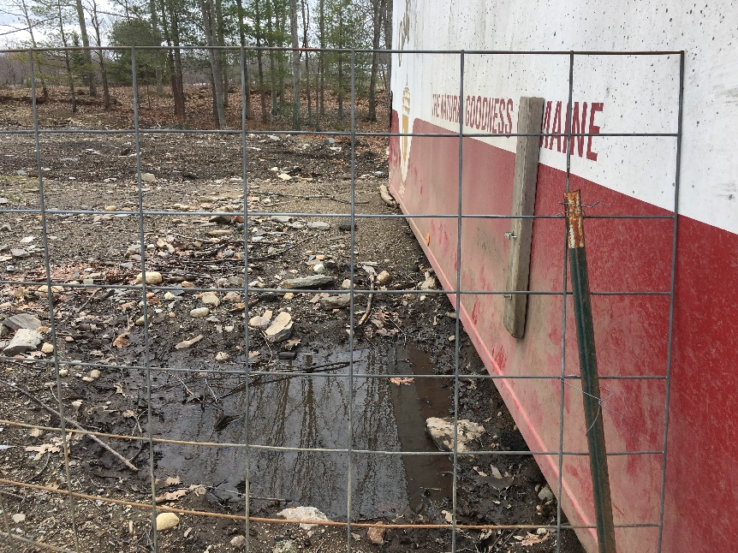
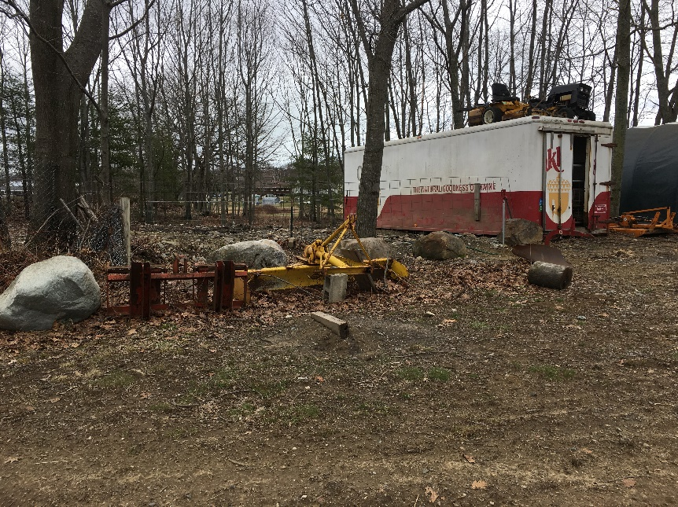

NPS Site Name &  Location | Describe the NPS Site & Conditions at the Site Causing Polluted Runoff to Reach Surface Waters | BMPs Recommended | Construction Cost Estimates:  Grant, Match, Total
Down Home Farm / irrigation pond | Down Home Farm maintains an historic impoundment of Trout Brook for their irrigation pond. The existing outlet control structure and associated culvert are failing. The farm road under which the culvert runs washes out in large storms, causing a significant amount of sediment to wash into Trout Brook. | Engineered stormwater controls will eliminate sediment loading into Trout Brook while allowing for fish passage. (Subtask 3c) | $14,000 319 grant  $12,000 in-kind match  $26,000 total
